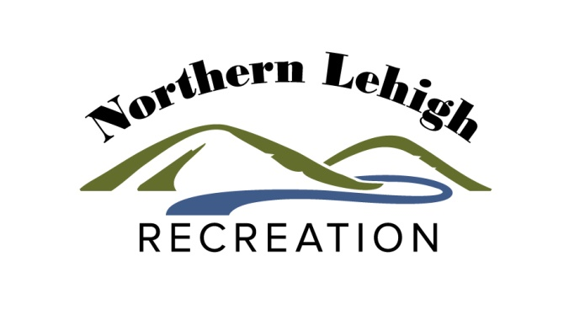

NORTHERN LEHIGH RECREATION
ADOPT-A-PARK PROGRAM

WHO CAN ADOPT A PARK?
Anyone interested in improving Northern Lehigh’s parks and contributing to the quality of life in Northern Lehigh!
WHAT CAN BE ADOPTED?
Entire parks or sections of parks can be adopted at the discretion of Slatington Borough and Washington Township. Sections of parks may include, but are not limited to: pavilions, open space, flower beds, trails, playgrounds, etc.
WHAT CAN BE DONE IN ADOPTED AREAS?
Groups or individuals who adopt sections of parks can help in many ways:
- Picking up trash
- Raking playground surfaces
- Reporting any hazards or graffiti/ vandalism to NLRA or municipal staff
- Pulling weeds
- Planting
SAFETY GUIDELINES
Review safety rules and guidelines with your group prior to beginning any project. These rules ae not all inclusive; please feel free to add any additional rules that will help keep you/your group safe while in a park.
- Children 15 years of age or younger. Must be supervised at all times.
- Always wear gloves and appropriate safety gear.
- Do not pick up trash near the street or near the curb.
- Do not pick up sharp objects, such as broken needles or glass.
- Do not run in front of vehicles entering a park or park staff working in a park.
- Wash hands thoroughly after a project is complete.
- Lift all objects with your legs, not your back.
- Wear sun block and/or a hat.
- Drink plenty of water and take frequent breaks.
- Work with partners whenever possible.
- Wear appropriate clothes and shoes, depending upon the project and the temperature.
- Seal all trash bags tightly prior to placing them next to the designated trash receptacle location for pick-up.
- Schedule projects with NLRA to ensure you are informed of any activities or construction projects that may be taking place in a park that day.
- Do not work at night or during potentially hazardous weather conditions.
- Do not block pathways or trails.
- Do not use power equipment or chemical when weeding in the parks.
- Report any hazards, graffiti or vandalism to NLRA immediately at 484-633-0093.
- Report any suspicious behavior to the Police.

PARKS AND TRAILS AVAILABLE FOR ADOPTION
Washington Township:
- Eagles Nest Park
- Slatedale Park
- Covered Bridge Trailhead
- Slate Heritage Trail

Slatington Borough:
- Victory Park
- West End Park
- Veterans Memorial Park
- D&L Slatington Trailhead
- Slate Heritage Trail
- Walnut Street Playground
- Covered Bridge Trailhead
HOW TO ADOPT A PARK
- Contact NLRA’s Executive Director, Lindsay Taylor at 484-633-0093 / nlrecauthority@gmail.com.

